**Young Vienna (Jung-Wien; das Junge Wien; Junges Wien; das junge Österreich; Jung-Österreich)**

Young Vienna was an informal, heterogeneous literary circle that existed in Vienna for little more than a decade, beginning in approximately 1890. Hermann Bahr and his protégés Hugo von Hofmannsthal, Arthur Schnitzler, Richard Beer-Hofmann, and Felix Salten formed the core of the group, while Karl Kraus and Peter Altenberg were later, peripheral participants. Many other writers, most now forgotten, were involved to varying degrees. These included Felix Dörmann, Friedrich Michael Fels, Paul Goldmann, Jacques Joachim, Eduard Michael Kafka, Julius Kulka, Rudolf Lothar, and Richard Specht. The group often met at Café Griensteidl and, later, Café Central.

Unlike the naturalists in Berlin and Munich, Young Vienna put forth no coherent literary program, manifestos, or theories, and their literary production ranged from naturalism and impressionism to aestheticism, symbolism, and décadence. The only commonality among the writers, according to Bahr, was that they wanted “in all things and at all costs to be modern” [in allen Dingen um jeden Preis modern zu sein].

Young Vienna had no clear beginning, but the founding of the short-lived journal *Moderne Dichtung* in 1890 in Brno/Brünn (later *Moderne Rundschau* based in Vienna) was pivotal. It started as an outlet for realism and naturalism in Austria, but increasingly published texts and criticism by many of the figures above. The editors (Kafka, Kulka, Joachim) gave Bahr a prominent voice from the start and also invited Henrik Ibsen to Vienna in 1891, signalling the pan-European context in which they viewed themselves. Moreover, analogous to Berlin, an attempt was made to found a *Freie Bühne* in Vienna.

The name “Young Vienna” gestures toward the *Junges Deutschland* movement of the *Vormärz* period and the later *Jüngstes Deutschland* movement of German naturalist writers centred in Berlin and Munich. As Gotthart Wunberg has noted, the name reflects a combination symptomatic of the time: it contextualises the transnationally “young”—the contemporary, new, and innovative—in its nationally localised particularism.

The Young Vienna circle was less interested than its German counterparts in programmatic theoretical positions and was more oriented toward practical literary and essayistic production. The Viennese favoured “inductive criticism” (Wunberg), taking the objects, events, and people they discuss as the basis for case-by-case reflection.

Unlike the George Circle, Young Vienna functioned through a wide network of personal and professional multipliers. Bahr, in particular, was a tireless advocate, mining his strong contacts to theatres and publishers (especially to S. Fischer, who published many of the Young Vienna authors).

After approximately 1902, the group, relatively diffuse from its beginnings, increasingly lost cohesion as its members moved on to other career opportunities (e.g., Hofmannsthal’s collaborations with the composer Richard Strauss; the end of Bahr’s journal *Die Zeit* in 1902).

**References and further reading**

Lorenz, Dagmar (1995) *Wiener Moderne*, Stuttgart: Metzler.

Wunberg, Gotthart ed. (1981) *Die Wiener Moderne. Literatur, Kunst und Musik zwischen 1890 und 1910*, Stuttgart: Reclam.

Wunberg, Gotthart (1976) “Einführung des Herausgebers,” *Das junge Wien. Österreichische Literatur- und Kunstkritik, 1887-1902*, 2 vols., ed. Gotthart Wunberg, Tübingen: Niemeyer. XXXVII-XC.

Digital images to include:

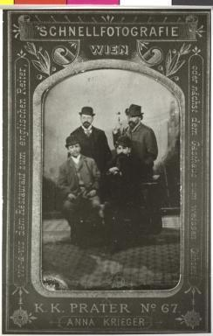

Titel Schnellfotografie aus dem Prater

Beschreibung Schnellphotographie (Ferrotypie) aus dem Prater. Gruppenbild: Richard Beer-Hofmann und Hermann Bahr stehend, Hugo von Hofmannsthal und Arthur Schnitzler sitzend

Datierung 1895

Sammlung Österreichische Nationalbibliothek Bildarchiv (bildarchivaustria.at)

Inventarnummer AS 155 C

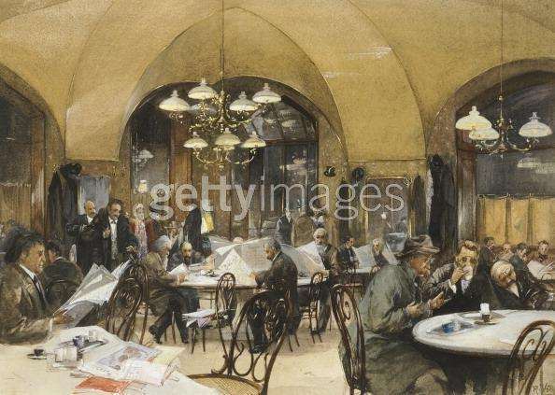

Café Griensteidl in Vienna. 1896. Reinhold Volkel. Austria. Watercolor.

(Photo by DeAgostini/Getty Images)

<http://www.gettyimages.com/detail/news-photo/griensteidl-cafe-in-vienna-by-reinhold-volkel-austria-19th-news-photo/142082091>